**Year 12 Examination, 2020**

**Question/Answer Booklet**

**MATHEMATICS SPECIALIST**

**Section Two: Calculator-assumed**

Student Name/Number: ______________________________________________

Teacher Name: ______________________________________________

**Time allowed for this section**

Reading time before commencing work: ten minutes

Working time for this section: one hundred minutes

**Materials required/recommended for this section**

**To be provided by the supervisor:** This Question/Answer Booklet

Formula Sheet (retained from Section One)

**To be provided by the candidate:**

Standard items: pens (blue/black preferred), pencils (including coloured), sharpener, correction fluid/tape, eraser, ruler, highlighters

Special items: drawing instruments, templates, notes on two unfolded sheets of A4 paper, and up to three calculators approved for use in the WACE examinations

**Important note to candidates**

No other items may be taken into the examination room. It is **your** responsibility to ensure that you do not have any unauthorised notes or other items of a non-personal nature in the examination room. If you have any unauthorised material with you, hand it to the supervisor **before** reading any further.

**Structure of this paper**

|  |  |  |  |  |  |
| --- | --- | --- | --- | --- | --- |
| Section | Number of questions available | Number of questions to be answered | Working time (minutes) | Marks available | Percentage of exam |
| Section One: Calculator-free | 8 | 8 | 50 | 50 | 35 |
| Section Two: Calculator-assumed | 11 | 11 | 100 | 100 | 65 |
|  | | | | | 100 |

**Instructions to candidates**

1. The rules for the conduct of School exams are detailed in the *_______________________________________School/College assessment policy*. Sitting this examination implies that you agree to abide by these rules.
2. Write your answers in this Question/Answer booklet preferably using a blue/black pen. Do not use erasable or gel pens.
3. You must be careful to confine your answer to the specific question asked and to follow any instructions that are specified to a particular question.
4. Show all your working clearly. Your working should be in sufficient detail to allow your answers to be checked readily and for marks to be awarded for reasoning. Incorrect answers given without supporting reasoning cannot be allocated any marks. For any question or part question worth more than two marks, valid working or justification is required to receive full marks. If you repeat any question, ensure that you cancel the answer you do not wish to have marked.
5. It is recommended that you do not use pencil, except in diagrams.
6. Supplementary pages for planning/continuing your answers to questions are provided at the end of this Question/Answer booklet. If you use these pages to continue an answer, indicate at the original answer where the answer is continued, i.e. give the page number.
7. The Formula sheet is not to be handed in with your Question/Answer booklet.

**Section Two: Calculator-assumed 65% (100 Marks)**

This section has **11** questions. Answer **all** questions. Write your answers in the spaces provided.

Supplementary pages for planning/continuing your answers to questions are provided at the end of this Question/Answer booklet. If you use these pages to continue an answer, indicate at the original answer where the answer is continued, i.e. give the page number.

Working time: 100 minutes.

**Question 9 (5 marks)**

Suppose that the complex number cis.

On an Argand diagram P represents the point , Q the point and R the point .

Determine the area of the quadrilateral OPRQ.

**Question 10 (8 marks)**

The plane $P$ intersects the coordinate axes at the points A , B and C .

(a) Use a cross product to find a vector **n** that is normal to the plane $P$. (2 marks)

(b) Determine the Cartesian equation for $P$. (2 marks)

(c) Find the co-ordinates of the point D on $P$ that is closest to the origin O. (3 marks)

(d) What is the distance of D from O? (1 mark)

**Question 11                                                                                                            (6 marks)**

The graph of is shown below.

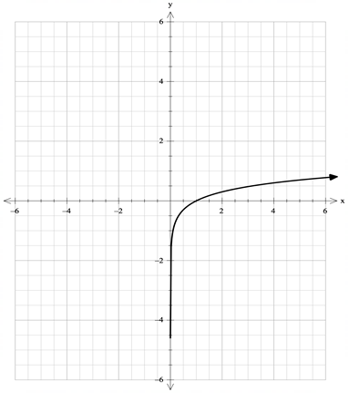

(a) Sketch on the same axes the graph of

. (3 marks)

(b) Sketch on the same axes the graph of . (3 marks)

**Question 12 (10 marks)**

The position vectors of two objects A and B at time  seconds are given by

$r_{A}\left(t\right)=\left(2+3t\right)i+(t-15)j+(11t-1)k$ and $r_{B}\left(t\right)=11i+(3-3t)j+(2+6t)k$**.**

(a) Show that the two paths intersect, but the objects do not collide. (5 marks)

(b) Find the minimum distance between the objects. (5 marks)

**Question 13 (9 marks)**

(a) Show that the set of points such that is a circle.

State the position of its centre and its radius. (5 marks)

(b) Show on an Argand diagram the set of points given by

.

Include on your sketch the co-ordinates of any significant points. (4 marks)

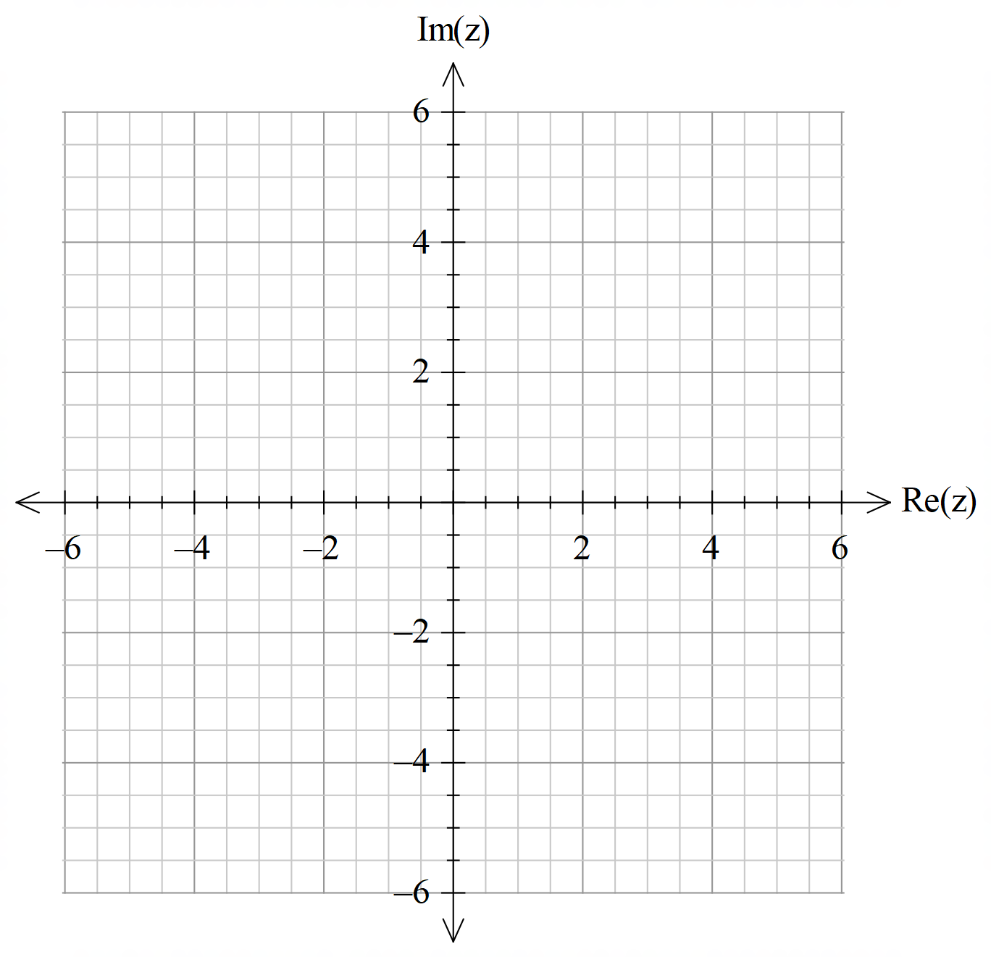

**Question 14                                                                                                         (15 marks)**

Consider the function

.

(a) Determine the location of all intercepts and critical points of . (6 marks)

(b) Determine the behaviours of as . (3 marks)

(c) Identify the vertical asymptote of . (1 mark)

(d) Sketch on the axes below the graph of  . (5 marks)

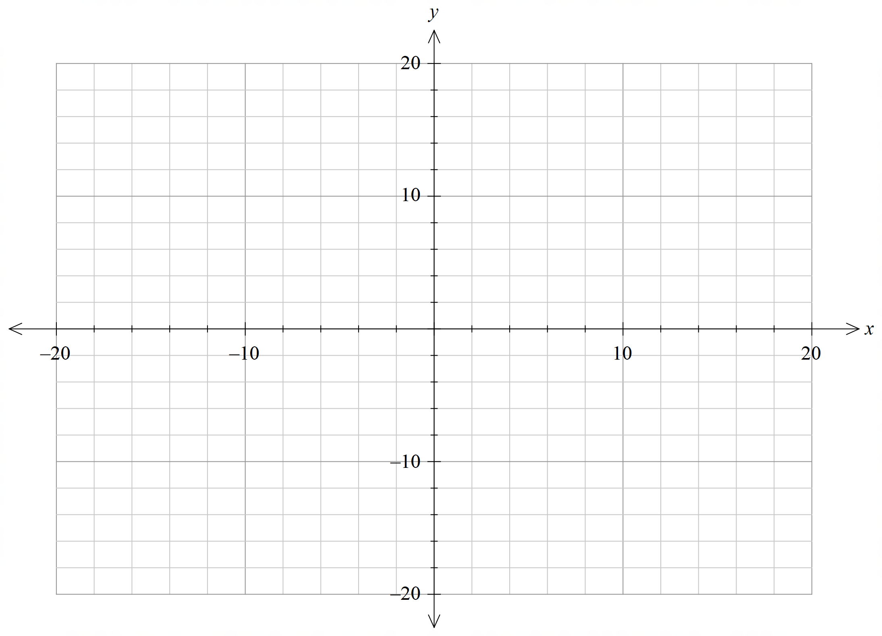

**Question 15 (8 marks)**

The linesand in the diagram below are altitudes of the triangle ABC; they are perpendicular to the sides AB, BC and CA respectively.

The altitudes meet at the point M, which is known as the orthocentre of the triangle ABC.

A $(7,$ 7,7)

$L_{3}$

${ L}_{1}$

M $(x,y,z)$

B (5,4,1) C (9,4,1)

${ L}_{2}$

Determine the coordinates of M.

**Question 16 (9 marks)**

Given that ,



1. Determine  in terms of and hence find . (2 marks)
2. Use de Moivre’s theorem to show that . (3 marks)
3. Use the expansion of  to show that (4 marks)

.

**Question 17 (12 marks)**

The position $r\left(t\right)$ of a model racing car at time  seconds is given by

**r** **i** +  **j**

where distances are measured in metres. The constant .

(a) Derive the Cartesian equation for the path traversed by the car. (2 marks)

(b) Describe the geometric shape of the path of the car. (1 mark)

(c) Obtain expressions for the velocity **v** and the acceleration **a $.$** (2 marks)

(d) Does the car travel in a clockwise or anticlockwise direction around its closed path? Justify your answer. (2 marks)

(e) Evaluate the value of $,$ correct to 3 significant figures, given that the car completes a circuit every 74 seconds. (2 marks)

(f) What is the maximum speed of the car? (3 marks)

**Question 18 (9 marks)**

Suppose that



where is a constant.

(a) Use your calculator to obtain sketches of the graphs of for the three values , and . Display these three graphs below, making sure you distinguish which graph corresponds to each value of .  (3 marks)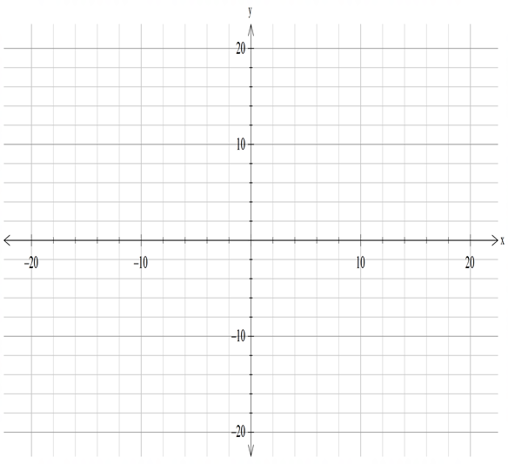

(b) For what values of  is the function one-to-one? Justify your answer by considering the derivative  (3 marks)

(c) Use your calculator to estimate the value of when . Give your answer correct to 2 decimal places.            (3 marks)

**Question 19 (9 marks)**

(a) Show that  is one root of the equation  where

. (3 marks)

(b) Hence solve giving all the answers in Cartesian form. (6 marks)

**END OF QUESTIONS**

**Additional working space**

Question number: __________________

**Additional working space**

Question number: __________________

**Additional working space**

Question number: __________________

**Acknowledgements**

© MAWA, 2020

This examination is Copyright but may be freely used within the school that purchases this licence.

* The items that are contained in this examination are to be used solely in the school for which they are purchased.
* They are not to be shared in any manner with a school which has not purchased their own licence.
* The items and the solutions/marking keys are to be kept confidentially and not copied or made available to anyone who is not a teacher at the school. Teachers may give feedback to students in the form of showing them how the work is marked but students are not to retain a copy of the paper or the marking guide until the agreed release date stipulated in the purchasing agreement/licence.

*Published by The Mathematical Association of WA*

*12 Cobbler Place, MIRRABOOKA 6061*